Conder Shou

cs3544

Intro to CS Java

Problem Set 3

*Chapter 4*

15.)

a.

Assuming that the problem actually means “40,000 samples/second” rather than “40,000 bits/second”, then the answer to part (a) is as follows:

40000 * 16 * 3 * 60 seconds = 115,200,000 bits

Here, we are multiplying each sample by the bit depth of 16, which is then multiplied by the amount of seconds the song lasts.

Without compression, it takes **115.2 million bits.**

With a compression scheme that works at a 5:1 compression ratio, it takes 115.2 million * 1/5, or **23,040,000 bits** instead.

b.

1200 * 800 = 960,000 pixels in the image

960,000 pixels * 24 bits/pixel = **23,040,000 bits** to store the image.

If the image actually takes only 2.4 Mbits….

Compression ratio = Uncompressed data size / Compressed data size

= 23040000 / (2.4 * 1000000 bits)

= 9.6

The compression ratio is **9.6 : 1**

24.)

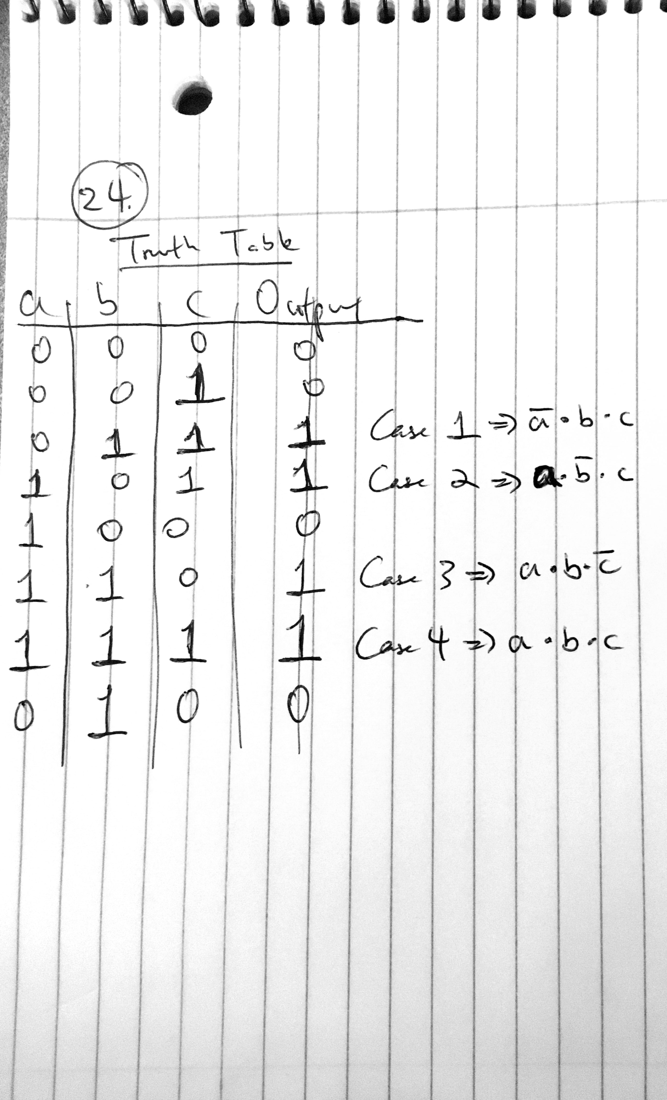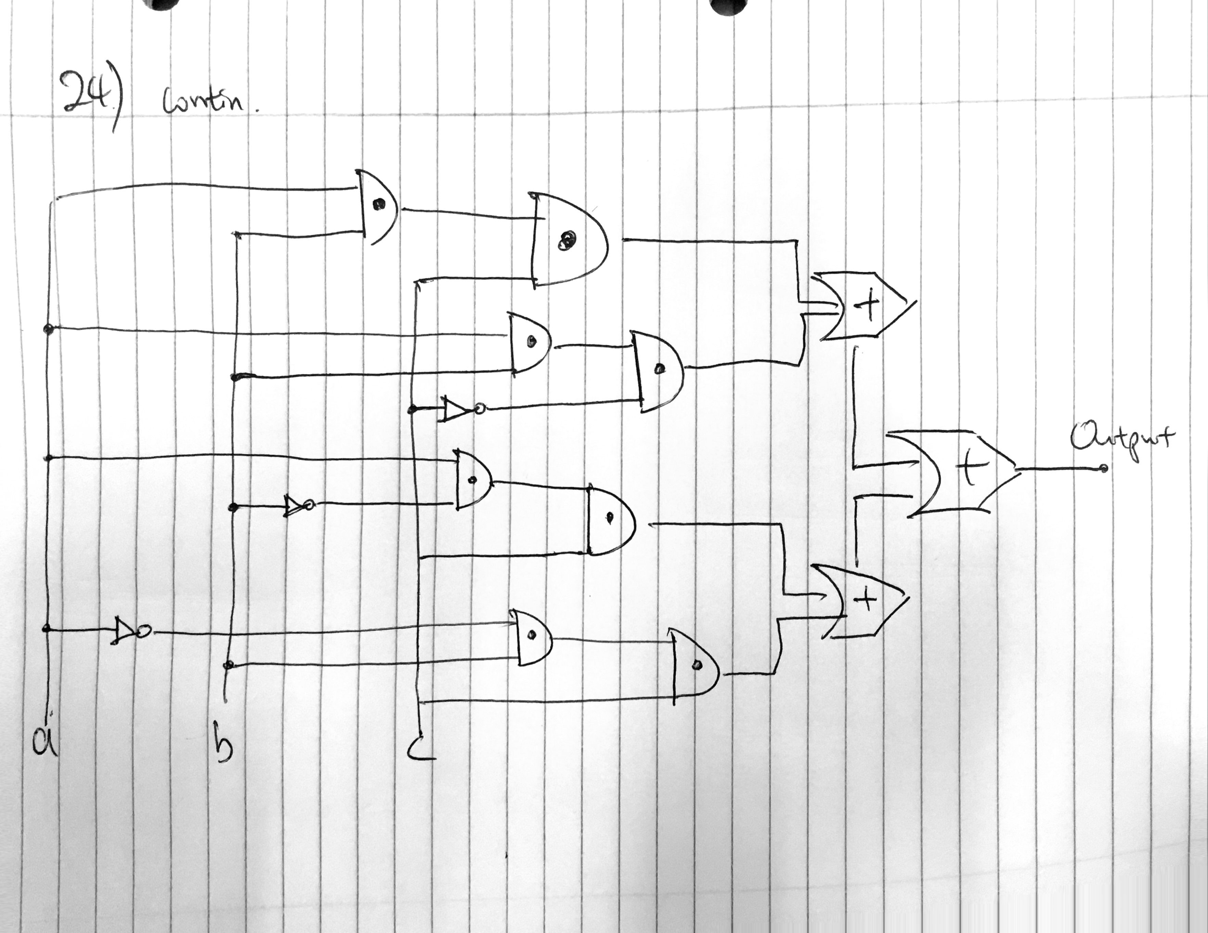

26.)

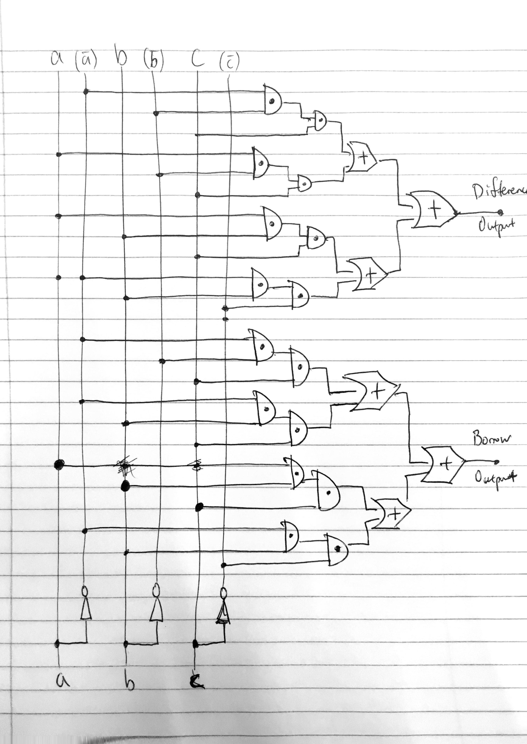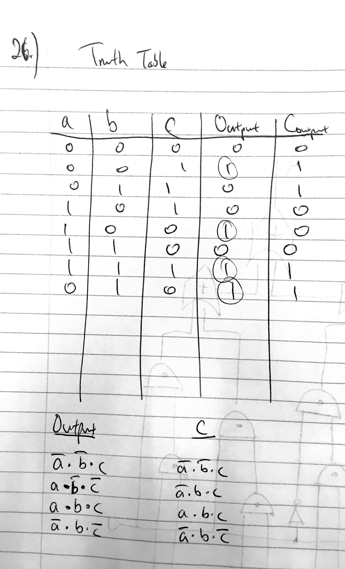

*Chapter 5*

2.)

a. 2^N = the address space of the computer; where N is the bits size of MAR.

log base 2 of 1000000 = 19.9

N = 19.9 ≈ **20 bits**

b.

log base 2 of 10 million = 23.3

N ≈ **24 bits**

We cannot round down to 23 bits. Otherwise, the MAR doesn’t have enough space.

c.

log base 2 of 100 million = 26.6

N ≈ **27 bits**

d.

log base 2 of 1 billion = 29.9

N ≈ **30 bits**

19.)

a.

The maximum of number of distinct operation codes executed by the processor of this machine is: 2^(number of bits).

That means that in this case, it is 2^6 = **64 distinct operation codes**

b.

The machine has a memory size of **2^18 bytes, or 262,144 bytes.**

c.

There are 8 bits in a byte.

(6 + 18 + 18) / 8 = 5.25 bytes.

Rounding up, it mean that **6 bytes** are required for each operation.

22.)

a.

LOAD 301

ADD 300

ADD 401

STORE 300

b.

COMPARE 300, 402

JUMPGT 52

MOVE 400, 301